**TASK 01**: Perform all the commands provided in the lab manual.

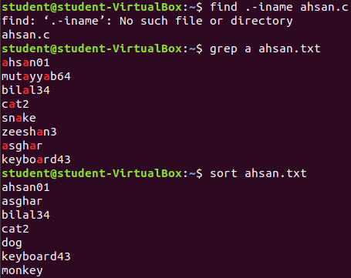

**TASK 02:** Create an empty file with a .txt extension. Write a shell script that would write the current date, student’s name and registration number into that file, while using variables for all three entries.

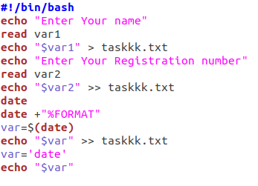 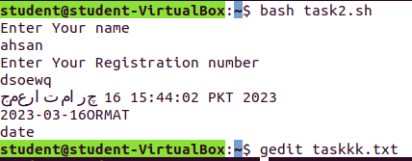

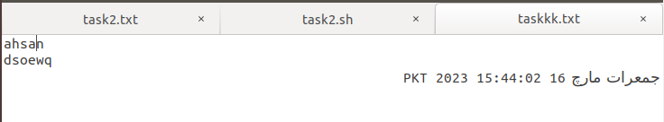

**TASK 03:** Create a .txt file and input ten lines of entry while mixing it with both alphanumeric characters. Sort the contents of the created file in an ascending order and write the sorted output into another file.

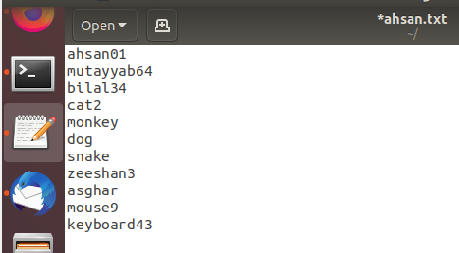

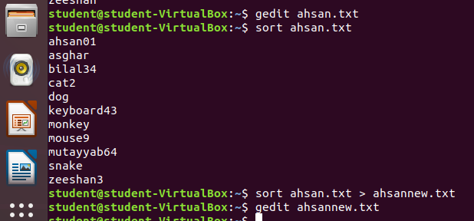

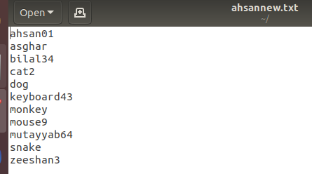

**TASK 04**: write a Program to Sum of Natural Numbers Using for Loop

